CSA-FIN-RD-0743

Canadian Space Agency
Office of the Chief Financial Officer (OCFO)

Cost Analysis Data Requirements (CADRe)

PART A

Mission : ZELVORA

Key Decision Point : KDP-E

EPMO Gate : G4

Daft 1.0

September 18, 2026

This Page Intentionally Left Blank
Revision History
Rev. | Description | Prepared by | Date
Draft 1.0 | Initial draft | MB | 19 Sept 2026

Table of Contents
This Page Intentionally Left Blank
1 Introduction 7
1.1 Purpose of this document 7
2 General Descriptive Information 7
2.1 Mission Overview 7
2.2 Strategic Objectives 8
2.3 Selected Mission Requirements 9
2.4 High-Level Mission Architecture 10
3 Space Segment Description 11
3.1 Spacecraft Bus 11
3.2 Payload 13
4 Launch Segment description 17
5 Ground Segment and Mission Operations 17
6 Systems Engineering and Project Management Approach 18
6.1 TRL Levels and Heritage 18
6.2 Phasing Logic and Naming conventions 18
6.3 CSA PRoject Milestones 19
6.4 Safety and Mission Assurance 19
6.5 Qualification and Acceptance Strategy, MODEL Philosophy 19
6.6 Sparing Strategies 20
6.7 Risk Assessment 20
6.8 Organizational Breakdown Structure 20

List of Figures
FIGURE PAGE
Figure 1 – Mission Concept 8
FIGURE 2 - KARVIX BUS 13
Figure 3 – Robotic Capture Arm 17

List of TABLES
Table 2 - Strategic Alignment 8
Table 3 – Selected SysteM Requirements 9

Introduction

Purpose of this document
CADRE Part A provides a concise, standardized synopsis of the mission or project to support costing and analysis activities. Its primary purpose is to consolidate information from multiple technical and programmatic source documents into a single, normalized reference.
Specifically, CADRE Part A:
- Summarizes key mission characteristics in a consistent and structured format
- Aggregates information drawn from multiple authoritative technical documents
- Reduces the need for analysts to repeatedly consult disparate source materials
- Ensures a common baseline description is used across analyses
- Improves efficiency, traceability, and consistency in downstream costing work
In practical terms, CADRE Part A functions as a time-saving reference document that enables analysts to quickly understand the mission context without re-interpreting or reconciling multiple source documents.

General Descriptive Information

Mission Overview
Project ZELVORA is an active debris-removal mission designed to reduce the number of inactive satellites and large pieces of debris in Low Earth Orbit (LEO). The mission will launch an advanced servicing spacecraft, known as the ZELVORA Orbital Spacecraft, which will travel to selected non-operational satellites, safely rendezvous with them, capture them, and lower their orbits. Once placed into a sufficiently low orbit, atmospheric drag will gradually pull the captured satellite toward Earth for re-entry.
The ZELVORA Orbital Spacecraft is designed to service multiple targets during a single mission. After completing the removal of one satellite, the spacecraft will use its propulsion system to transfer to another target and repeat the process. This approach allows one servicing vehicle to address several pieces of debris rather than requiring a separate launch for every object.
The mission builds on technologies demonstrated by previous orbital debris-removal efforts, including Astroscale's ELSA-d, which demonstrated rendezvous and capture operations, and ESA's ClearSpace-1, which is designed to capture and remove an inactive object from orbit. ZELVORA advances these concepts by combining rendezvous, robotic capture, orbital maneuvering, and multi-target operations into one integrated mission.
The primary objective of Project ZELVORA is to demonstrate a practical method for removing large inactive objects from Earth's increasingly congested orbital environment. By safely lowering the orbits of selected satellites and allowing atmospheric drag to complete their removal, ZELVORA will demonstrate how future servicing spacecraft could help maintain a safer and more sustainable space environment.

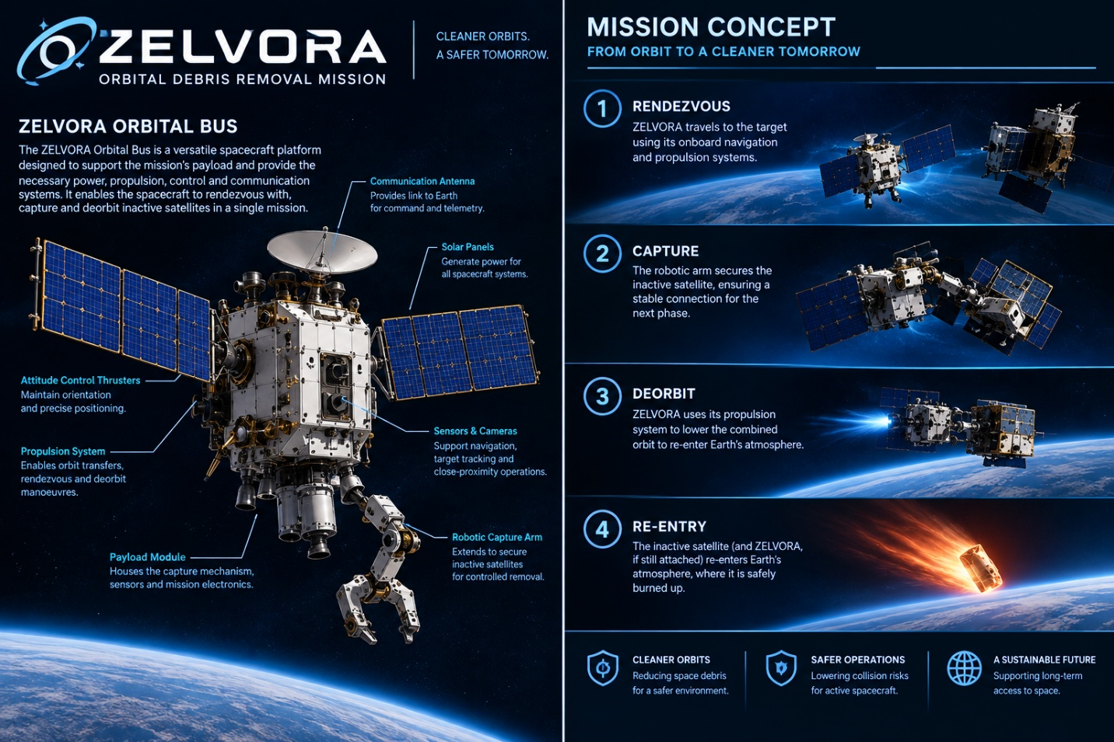
Figure 1 – Mission Concept

Strategic Objectives
Consistent with the Government of Canada's Space Policy Framework, the WFS mission supports the following 2 main strategic goals:

Table 2 - Strategic Alignment
 | Strategic Goals | Space Strategy
1 | SOLVE | Harness space to solve everyday challenges for Canadians.  ZELVORA addresses the practical problem of space debris and inactive satellites. Removing debris can help make orbital space safer and more sustainable for future satellite operations.
2 | ENABLE | Position the space sector to help grow the economy
  The mission develops in-orbit servicing and debris-removal technology, which could support the growth of Canada's space industry and create future commercial opportunities for satellite servicing.

Additionally, Project ZELVORA contributes to Stewardship, Management and Accountability through international partnerships.

Selected Mission Requirements
The following represents a summary of selected mission requirements. The complete and authoritative set of requirements is contained in the Mission Requirements Document.
- Launch and deploy the ZELVORA Orbital Bus into its designated Low Earth Orbit.
- Rendezvous and safely capture selected inactive satellites using the spacecraft's navigation and robotic systems.
- Deorbit captured satellites by lowering their orbits to a trajectory that results in controlled atmospheric re-entry.
- Service multiple targets during a single mission while maintaining safe operations and sufficient spacecraft resources.
- Demonstrate reliable and sustainable debris removal without creating additional orbital debris or unacceptable risks to other spacecraft and people on Earth.

Table 3 – Selected SysteM Requirements
# | Requirement Name | Requirement Description
1 | Multi-Target Removal | ZELVORA shall be capable of capturing and deorbiting at least 5 inactive satellites during one mission.
2 | Orbital Rendezvous | ZELVORA shall be capable of safely rendezvousing with selected inactive satellites in Low Earth Orbit (LEO).
3 | Satellite Capture | ZELVORA shall be capable of securely capturing non-cooperative satellites using its robotic capture system.
4 | Deorbit Capability | ZELVORA shall be capable of lowering the orbit of each captured satellite to a planned disposal trajectory that results in atmospheric re-entry.
5 | Orbital Maneuvering | ZELVORA shall have sufficient propulsion capability to transfer between multiple targets and perform required deorbit maneuvers.
6 | Precision Navigation | ZELVORA shall be capable of determining the position and relative motion of target satellites during rendezvous and capture operations.
7 | Mission Lifetime | ZELVORA shall have sufficient power, propellant, communications, and thermal-control resources to complete its planned mission.
8 | Debris Prevention | ZELVORA shall conduct capture and disposal operations without intentionally creating additional long-lived orbital debris.

High-Level Mission Architecture
Owned and operated by CSA, the mission consists of
- A Government Segment: consisting of government resources for oversight and their associated management costs such as T&L
- A Space Segment: consisting of four spacecrafts with a platform/bus and an infrared instrument.
- A Launch Segment: consisting of the launcher and launch service provider.
- A Ground Segment: consisting of facilities and equipment to plan and command acquisitions, as well as, to receive, archive and process data acquired by the satellite.
- An Ops Segment: consisting of personnel to handle real-time operations and some O&M costs
- A Science Segment: consisting of scientific leadership, research teams, and supporting infrastructure responsible for mission science planning, calibration and validation, data analysis, scientific data products, user support, and the maximization of scientific return from the mission.

Space Segment Description
The space segment consists of a bus and a payload.

Spacecraft Bus
The KARVIX Orbital Bus provides the common spacecraft platform required to support the ZELVORA active debris-removal mission. The bus supplies the power, control, communications, propulsion, thermal management, and autonomous capabilities necessary for the spacecraft to operate in Low Earth Orbit and perform repeated rendezvous and deorbit operations.
Key functions of the bus include:
- Electrical power generation and distribution
- Spacecraft pointing and attitude control
- Data handling and storage
- Communications with Earth
- Propulsion and orbit maintenance
- Thermal control
- Fault management and autonomy

Spacecraft pointing and attitude control
The attitude control system maintains the orientation and stability of the KARVIX spacecraft during all phases of the mission. Sensors determine the spacecraft's orientation, while reaction wheels and attitude-control thrusters provide the necessary control. Precise pointing is particularly important during rendezvous and satellite capture, where the spacecraft must maintain a controlled position and orientation relative to an inactive satellite. The system also supports accurate pointing of communications antennas and navigation sensors.

Data handling and storage
The KARVIX data-handling system acts as the spacecraft's central computing and information-management system. It receives commands from mission control, monitors the status of onboard systems, and processes information collected by sensors and cameras. Mission data and spacecraft health information are stored onboard before being transmitted to Earth. The system also supports autonomous operations by allowing KARVIX to process navigation and spacecraft-status information without requiring continuous instructions from ground operators.

Communications with Earth
The communications system provides the connection between KARVIX and ground stations on Earth. It allows mission controllers to send commands to the spacecraft and receive telemetry concerning spacecraft health, position, power, temperature, and mission progress. Communications are maintained throughout normal spacecraft operations and provide a means of monitoring critical rendezvous and deorbit activities. The system also supports communication during contingency and safe-mode operations.

Propulsion and orbit maintenance
The propulsion system provides the changes in velocity required for KARVIX to travel between selected target satellites and perform deorbit operations. Propulsion manoeuvres allow the spacecraft to adjust its orbital altitude and trajectory, rendezvous with inactive satellites, and move between multiple targets during the mission. Following capture, the propulsion system lowers the orbit of the combined spacecraft and target until atmospheric drag can cause the target to re-enter Earth's atmosphere. Propulsion also provides orbit-maintenance and collision-avoidance capabilities when required.

Thermal control
The thermal-control system maintains the KARVIX spacecraft and its equipment within acceptable operating temperatures. The spacecraft experiences changing thermal conditions as it moves between sunlight and Earth's shadow, while onboard electronics and other equipment generate heat during operation. Insulation, heat-transfer paths, and radiators are used to manage these temperature variations. Maintaining appropriate temperatures protects sensitive electronics, batteries, propulsion components, and the robotic capture equipment throughout the mission.

Fault management and autonomy
The fault-management and autonomy system monitors the health and performance of KARVIX's major subsystems. It can identify abnormal conditions and take predefined actions to protect the spacecraft without waiting for instructions from Earth. If a serious fault occurs, the spacecraft can enter a safe operating mode, reduce non-essential activities, and maintain critical functions until the problem can be assessed. Autonomous capabilities are also used during rendezvous and close-proximity operations, allowing KARVIX to respond to changing conditions while approaching and capturing an inactive satellite.

Overall Bus Function
Together, these seven bus systems provide the infrastructure required for KARVIX to operate as an autonomous orbital servicing spacecraft. The electrical, attitude-control, computing, communications, propulsion, thermal, and fault-management systems work together to support the ZELVORA mission from launch through satellite rendezvous, capture, deorbit, and completion of the mission.
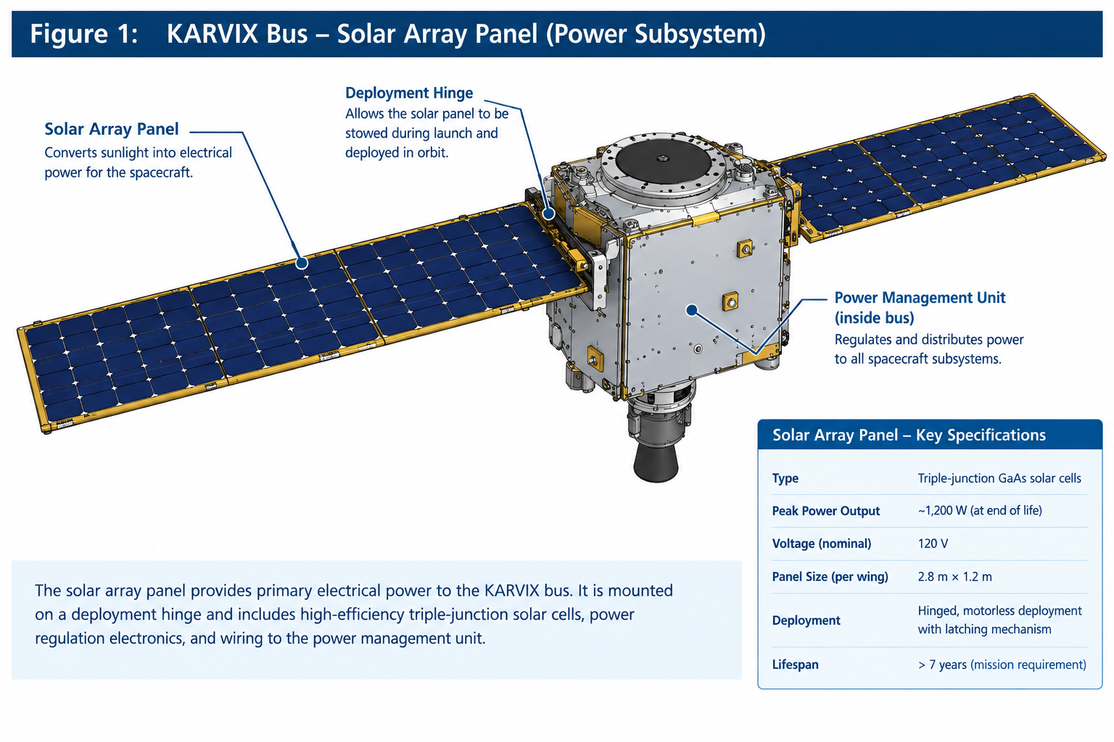
Figure 2 – Karvix Bus

Payload

Payload System Overview
The ZELVORA payload system contains the mission-specific equipment required to locate, approach, capture, and assist in the disposal of inactive satellites in Low Earth Orbit (LEO). The KARVIX Orbital Bus provides the spacecraft with power, propulsion, communications, attitude control, thermal control, and data handling, while the payload performs the direct interaction with the target.
The payload is designed to work with non-operational satellites that may no longer be able to control their own position or orientation. It combines imaging sensors, relative-navigation equipment, a robotic capture mechanism, payload electronics, and structural support systems.
The major payload elements are:
- Target detection and imaging system
- Relative-navigation and proximity sensors
- Robotic capture system
- Target interface and capture mechanism
- Payload electronics and control
- Payload structural support
- Payload safety system
Together, these systems allow ZELVORA to safely approach and establish a physical connection with selected orbital debris.

Target Detection and Imaging System
The target detection and imaging system provides the spacecraft with visual information about the selected satellite. Cameras mounted on the spacecraft are used during the approach to identify the target and determine its position and orientation.
As the spacecraft gets closer, higher-resolution imaging is used to monitor the target's movement and rotation. This is important because an inactive satellite may be tumbling or slowly changing orientation.
The imaging system supports:
- Target identification
- Relative-position determination
- Monitoring of target movement
- Final approach
- Capture verification
- Post-capture inspection
Information from the cameras is provided to the spacecraft's onboard computer and can also be transmitted to ground operators.

Relative Navigation and Proximity Sensors
The relative-navigation system determines the position and movement of the target relative to ZELVORA. It combines information from cameras and proximity sensors to provide accurate measurements during close-range operations.
The system monitors:
- Distance to the target
- Relative direction
- Closing speed
- Target orientation
- Target rotation
- Capture-interface position
This information is supplied to the spacecraft's guidance and attitude-control systems. As ZELVORA approaches the target, navigation measurements become increasingly important for maintaining a controlled position and preventing accidental contact.
Using multiple sensors also provides additional reliability if one sensor produces poor-quality information because of lighting, target orientation, or other conditions.

Robotic Capture System
The robotic capture system is the primary mechanical component of the ZELVORA payload. Its purpose is to establish a secure physical connection with an inactive satellite.
The system consists of a robotic arm or articulated mechanism, actuators, an end-effector, position sensors, and a capture mechanism. The robotic arm allows the capture device to be moved toward a suitable structural region of the target.
During capture, the arm moves at controlled speeds to reduce unwanted forces. The end-effector establishes contact with the target and secures the connection.
The capture system must also account for target movement. If the inactive satellite is rotating or moving slightly during the approach, the robotic mechanism must accommodate this motion while maintaining a stable connection.

Target Interface and Capture Mechanism
The target interface is the part of the payload that makes direct contact with the inactive satellite. Before a mission, the target would be analyzed to identify an appropriate structural region for capture.
During the final approach, navigation sensors guide the robotic system toward this region. Once contact is established, the capture mechanism secures the target so that the spacecraft can control the combined system during orbital maneuvers.
Sensors within the capture mechanism confirm that the connection has been successfully established. If the capture conditions are outside the expected limits, the spacecraft can stop the operation rather than continuing an unsafe maneuver.
The target interface is therefore designed to provide a controlled and secure connection between ZELVORA and the captured satellite.

Payload Electronics and Control
The payload electronics control the sensors and robotic capture equipment and provide the interface between the payload and the KARVIX Orbital Bus.
The electronics collect information from the cameras, navigation sensors, robotic-arm sensors, and capture mechanism. This information is processed by the spacecraft's computing system and used to support navigation and capture operations.
The system can control functions such as:
- Robotic-arm movement
- Capture-head positioning
- Capture activation
- Actuator monitoring
- Capture confirmation
- Payload health monitoring
The payload electronics work together with the spacecraft's power, communications, attitude-control, and fault-management systems to ensure that the capture system operates only when the spacecraft is in an appropriate state.

Payload Structural Support
The payload structural system provides the mounting points for the cameras, sensors, robotic arm, and other mission equipment.
The structure must withstand launch loads as well as forces generated during orbital operations and target capture. Particular attention is given to the robotic capture system because forces produced during contact with a target can be transferred into the spacecraft structure.
The payload structure also positions the cameras and sensors so that they have appropriate views of the target while providing the robotic arm with sufficient range of motion.

Payload Safety System
The payload safety system is designed to reduce the possibility of accidental contact or an unsuccessful capture creating additional orbital debris.
Before the robotic system is deployed, ZELVORA verifies that conditions such as spacecraft attitude, relative distance, navigation accuracy, power availability, and system health are suitable for the operation.
During capture, the spacecraft continuously monitors the target and robotic mechanism. If an unexpected condition occurs, the capture operation can be paused or aborted and the robotic system returned to a safe configuration.
Following successful capture, the spacecraft confirms that the target is securely attached before performing major orbital maneuvers.

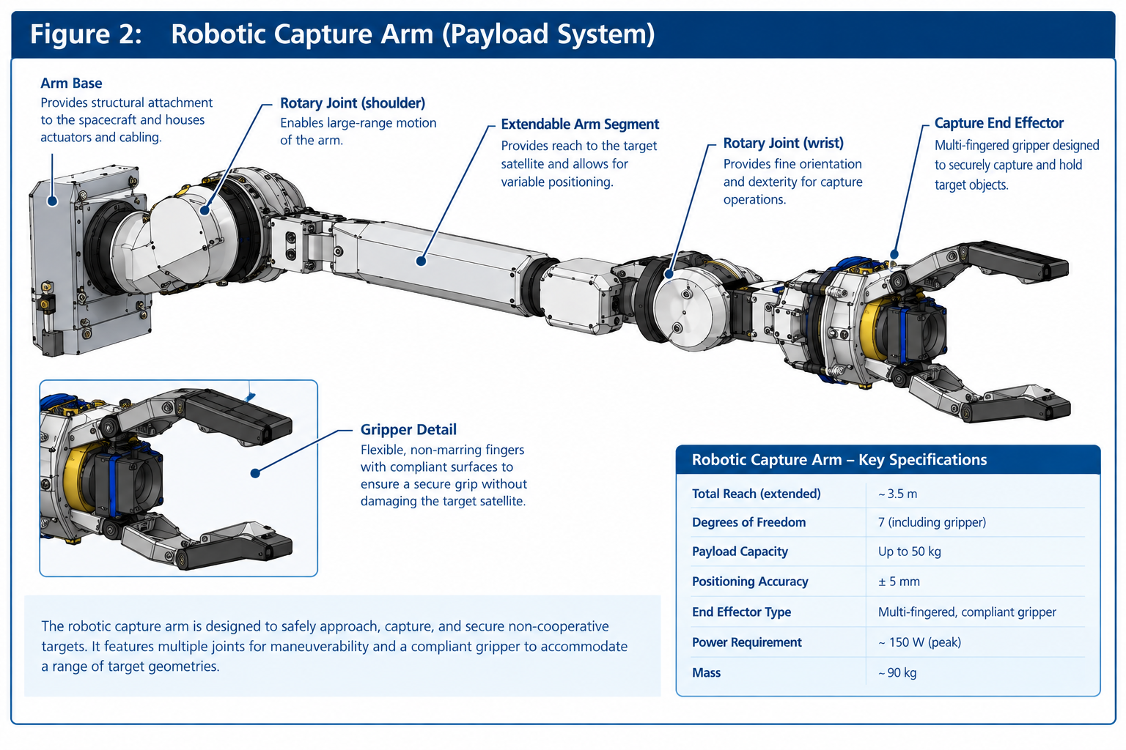 Figure 3 – Robotic capture arm

Launch Segment description
The ZELVORA launch segment begins with the spacecraft being integrated with its launch vehicle and prepared for deployment into Low Earth Orbit (LEO). Following launch, the spacecraft is released at its designated orbit and begins initial system checks. The KARVIX Orbital Bus then deploys its solar arrays, establishes communication with ground control, and verifies the health of its major systems. Once commissioning is complete, ZELVORA transitions into its operational orbit and prepares for its first debris-removal operation.

Ground Segment and Mission Operations
The ZELVORA ground segment provides the communication, monitoring, planning, and control functions required to operate the spacecraft throughout its mission. Ground stations maintain communication with ZELVORA and receive telemetry containing information about the spacecraft's health, position, power levels, propulsion system, payload, and other critical systems. Commands and mission updates are transmitted from the ground to the spacecraft through these communication links.
Mission operations are managed by a ground control team responsible for planning orbital maneuvers, monitoring spacecraft performance, and coordinating debris-removal activities. Before each target encounter, operators review the target's orbital position and prepare the required rendezvous and capture sequence. During critical operations, such as final approach and satellite capture, the ground team monitors telemetry and sensor data while ZELVORA's onboard autonomous systems handle rapid responses that cannot depend on continuous communication with Earth.
After a successful capture, mission operators verify spacecraft and target status before authorizing the deorbit maneuver. The ground segment also maintains mission records and evaluates system performance after each operation. This combination of ground-based planning and onboard autonomy allows ZELVORA to safely conduct repeated debris-removal operations while maintaining continuous oversight from Earth.

Systems Engineering and Project Management Approach

TRL Levels and Heritage
ZELVORA has an estimated overall TRL of 6, using mature spacecraft technologies combined with less-proven robotic capture and autonomous rendezvous systems. Its technology heritage is based on previous orbital servicing and debris-removal missions, including demonstrated rendezvous and capture technologies.

Phasing Logic and Naming conventions
The following are the phases in terms of costing:
Costing Nomenclature | Phase Description according to Costing Standards | Corresponding Name for Project team
PREP 1 | Prototyping Activities (before Gate 1) | N/A
PREP 2 | Prototyping Activities (during Phase 0/A) | N/A
Phase 0 | Concept & Feasibility Studies | Phase 0
Phase A | System Definition | Phase A
Phase B | Preliminary Design | Phase B
Phase C | Detailed Design | Phase C
MAIT | Manufacturing, Assembly, Integration and Test (of Canadian Systems, Subsystems and Components) | Phase D
SAIT | Segment Level Assembly, Integration and Test (begins with System Integration review) | Phase D
LEOP | Launch and Early Operations (incl. commissioning) | Phase D
Phase E | Nominal Operations (per design life) | Phase E
Phase X | Extended operations (mission extension) | Extended ops
Phase F | Disposal | Phase F

CSA PRoject Milestones
The project has not created a schedule baseline yet. Assuming instrument level milestones will drive the CSA need dates.
Instrument Phases |  | Major Milestone | Milestone Date
Phase 0 | MCR | Mission Concept Review | 10/20/2020
Phase A | SRR | System Requirements Review | 07/15/2022
 |  | Mission Rebaseline | 09/19/2022
Phase B | PDR | Preliminary Design Review | 10/18/2023
Phase C | CDR | Critical Design Review | 12/12/2024
MAIT | MRR | Manufacturing readiness Review | 06/24/2025
MAIT | PSR | Pre-Ship Review of systems to Prime | 10/14/2025
SAIT | SIR | System Integration Review | 06/23/2026
SAIT | AR | Acceptance Review | 09/24/2026
SAIT | PSR | Pre-Ship Review of S/C to Launch site | 01/15/2027
LEOP | L | Launch | 03/01/2027
LEOP | CR | Commissioning Review | 03/14/2027
Phase E |  | Start of Nominal Ops | 04/13/2027
Phase E |  | End of Nominal Ops | 05/04/2028
Phase X |  | End of Life | 10/27/2031

Safety and Mission Assurance
Initial assessments is assumed to be Mission Class: B

Qualification and Acceptance Strategy, MODEL Philosophy
ZELVORA will follow a Class B development and verification approach based on the GSFC GOLD Rules, using progressive testing from individual units through subsystem and full spacecraft levels. Engineering Models (EM) will be used to verify interfaces and system functionality, while Qualification Models (QM) will be used for higher-risk hardware such as the robotic capture system. The Protoflight/Flight Model (PFM) will undergo functional, environmental, and flight-acceptance testing before launch.
Testing will progress from unit and subsystem testing to spacecraft-level testing, including vibration, thermal-vacuum, functional, and end-to-end mission testing. Critical functions such as rendezvous, capture, communications, propulsion, and fault management will be tested using flight software where practical.
A Structural-Thermal-Optical Performance (STOP) analysis will also be performed to evaluate how structural deformation and thermal conditions could affect spacecraft and payload performance. This analysis will be particularly important for ZELVORA's cameras, navigation sensors, and robotic capture mechanism, ensuring that thermal and structural changes do not compromise alignment or capture performance.
ZELVORA will use selective redundancy and fault tolerance for mission-critical systems such as power, communications, command and data handling, and attitude control. Less critical components may remain single-string to reduce mass and complexity, with the final redundancy approach determined through system-level risk and reliability analysis.

Sparing Strategies
ZELVORA will use a selective sparing and redundancy strategy to improve mission reliability while controlling spacecraft mass, cost, and complexity. Not every subsystem will require a complete backup; instead, redundancy will be applied to functions where a single failure could significantly affect spacecraft safety or mission success. Critical systems such as command and data handling, electrical power, communications, and attitude control will be designed with appropriate backup capabilities where practical. For example, backup communication paths or redundant processing capabilities could allow the spacecraft to continue operating if a primary component fails.
For the payload, redundancy will focus on the most important functions required for target detection, navigation, and capture. Multiple sensors can provide overlapping measurements so that the loss or degradation of one sensor does not immediately end a mission operation. The robotic capture system will also incorporate fault detection and safe configurations to reduce the consequences of actuator or mechanism failures. Less critical equipment may remain single-string to avoid unnecessary mass and hardware.
Sparing will also be supported through fault detection, isolation, and recovery (FDIR). The spacecraft will monitor system health and automatically transition affected equipment to backup or safe modes when required. This approach allows ZELVORA to maintain useful functionality following individual failures while keeping the overall spacecraft design practical for a Class B mission.

Risk Assessment
The project team shall produce a risk register (ref CADRe part C).

Organizational Breakdown Structure
Canada has established cooperation with both EOSA and JSRA, including collaboration in robotics, Earth observation, space technology, and sustainable space activities.

ZELVORA Project Partners: Space Agencies and Government Organizations

Partner | Type | Role in ZELVORA
Canadian Space Agency (CSA) | Government / Prime | Leads ZELVORA and is responsible for spacecraft design, construction, integration, testing, and mission operations.
European Orbital Systems Agency (EOSA) | International Agency | Provides fictional international expertise in orbital debris removal and spacecraft servicing.
Japan Space Robotics Agency (JSRA) | International Agency | Supports fictional research in robotic capture and autonomous rendezvous technologies.
Northstar Orbital Technologies | Industrial Vendor | Develops propulsion and orbital maneuvering hardware.
Aetheris Space Robotics | Industrial Vendor | Develops the robotic capture arm and capture mechanism.
Polarion Avionics Corporation | Industrial Vendor | Supplies avionics, flight computers, and payload electronics.
Borealis Vision Systems | Industrial Vendor | Develops cameras and optical navigation sensors.
Canterra Space Communications | Industrial Vendor | Supports spacecraft communication hardware and ground interfaces.
Northern Institute of Space Engineering | University | Researches autonomous rendezvous, guidance, and navigation.
Laurentia University of Aerospace Technology | University | Supports robotic capture research and spacecraft testing.
Boreal Technical University | University | Conducts structural, thermal, and spacecraft-environment research.
Canadian Orbital Safety Directorate (COSD) | Canadian OGD | Provides fictional orbital tracking and conjunction-monitoring support.
Canadian Space Environment Office (CSEO) | Canadian OGD | Provides fictional space-weather and orbital-environment information.
National Aerospace Research Directorate (NARD) | Canadian OGD | Provides independent engineering analysis, testing support, and technical review.

Principal Investigators

Principal Investigator | Area of Responsibility | Affiliated International Agency
Dr. Maya Laurent | Autonomous Rendezvous & Navigation | European Orbital Systems Agency (EOSA)
Dr. Daniel Okafor | Robotic Capture Systems | Japan Space Robotics Agency (JSRA)
Dr. Elise Tremblay | Orbital Debris & Space Sustainability | European Orbital Systems Agency (EOSA)
Dr. Nathan Chen | Spacecraft Structures & Thermal Systems | Japan Space Robotics Agency (JSRA)
Dr. Sofia Moreau | Propulsion & Orbital Maneuvering | European Orbital Systems Agency (EOSA)
Dr. Marcus Bennett | Flight Software & Autonomy | Japan Space Robotics Agency (JSRA)
Dr. Amélie Rousseau | Spacecraft Power & Avionics | European Orbital Systems Agency (EOSA)
Dr. Liam Carter | Mission Operations & Ground Systems | Japan Space Robotics Agency (JSRA)

